**Suppose you have been given a fair coin and you want to find out the odds of getting heads. Which of the following option is true for such a case?**

odds will be 0

odds will be 0.5

odds will be 1

None

**Suppose, You applied a Logistic Regression model on a given data and got a training accuracy X and testing accuracy Y. Now, you want to add a few new features in the same data. Select the option(s) which is/are correct in such a case.**

Training accuracy increases

Training accuracy increases or remains the same

Testing accuracy decreases

Testing accuracy increases or remains the same

**The below figure shows AUC-ROC curves for three logistic regression models. Different colors show curves for different hyper parameters values. Which of the following AUC-ROC will give best result?**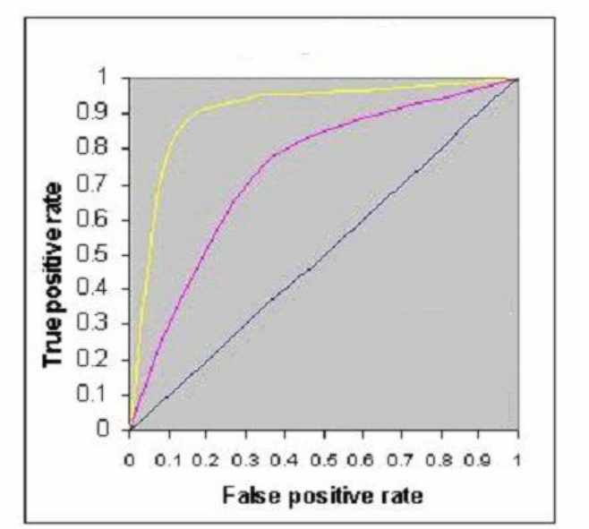

Yellow

Pink

Black

All are same

**Suppose, Following graph is a cost function for logistic regression. How many local minimas are present in the graph?**

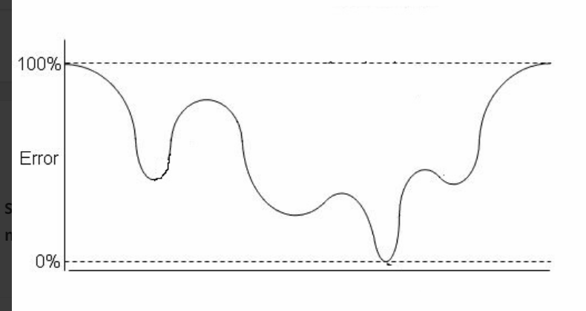

1

2

3

4

**Is Logistic regression a supervised machine learning algorithm?**

answer choices

TRUE

FALSE

**Suppose that in our sample, following a logistic regression analysis, the odds for girls of having a positive attitude to school were 1.25. What proportion of girls would be expected to have a positive attitude?**

25%

35%

45%

55%

Just as odds can be generated from proportions by: odds= p/(1-p), so equally proportions can be generated from odds by: p= odds/(1+odds). Therefore, 1.25/(1+1.25)= 55%

**Logistic regression is used for ___?**  
(A) classification  
(B) regression  
(C) clustering  
(D) All of these

**Logistic Regression is a Machine Learning algorithm that is used to predict the probability of a ___?**  
(A) categorical independent variable  
(B) categorical dependent variable.  
(C) numerical dependent variable.  
(D) numerical independent variable.

**You are predicting whether an email is spam or not. Based on the features, you obtained an estimated probability to be 0.75. What’s the meaning of this estimated probability? (select two)**  
(A) there is 25% chance that the email will be spam  
(B) there is 75% chance that the email will be spam  
(C) there is 75% chance that the email will not be spam  
(D) there is 25% chance that the email will not be spam

**In a logistic regression model, the decision boundary can be ___.**  
(A) linear  
(B) non-linear  
(C) both (A) and (B)  
(D) none of these

**What’s the cost function of the logistic regression?**  
(A) Sigmoid function  
(B) Logistic Function  
(C) both (A) and (B)  
(D) none of these

**you are predicting whether an email is spam or not. Based on the features, you obtained an estimated probability to be 0.75. What’s the meaning of this estimated probability? The threshold to differ the classes is 0.5.**  
(A) The email is not spam  
(B) The email is spam  
(C) Can’t determine  
(D) both (A) and (B)

**What’s the the hypothesis of logistic regression?**  
(A) to limit the cost function between 0 and 1  
(B) to limit the cost function between -1 and 1  
(C) to limit the cost function between -infinity and +infinity  
(D) to limit the cost function between 0 and +infinity

**In a logistic regression, if the predicted logit is 0, what’s the transformed probability?**  
(A) 0  
(B) 1  
(C) 0.5  
(D) 0.05

**A linear regression model assumes “a linear relationship between the input variables and the single output variable.” What’s the meaning of this assumption?**  
(A) The output variable can’t be calculated from a linear combination of the input variables  
(B) The output variable can be calculated from a linear combination of the input variables  
(C) Input variables can be calculated from a linear combination of the output variables  
(D) Output variable = sum of the input variables

**In a simple linear regression problem, a single input variable (x) and a single output variable (y), the linear equation would be y = ax + b; where a and b are _______ and ________ respectively. (select two)**  
(A) bias Coefficient, feature coefficient  
(B) feature coefficient, bias Coefficient  
(C) slope, y-intercept  
(D) y-intercept, slope

**For a regression line through the data, the vertical distance from each data point to the regression line is called residual. (i) Square the residual, and (ii) sum all of the squared errors together. This is the quantity that ordinary least squares seek to _____?**  
(A) minimize  
(B) maximize  
(C) increase  
(D) None of these

**For a linear regression model, start with random values for each coefficient. The sum of the squared errors is calculated for each pair of input and output values. A learning rate is used as a scale factor and the coefficients are updated in the direction towards minimizing the error. The process is repeated until a minimum sum squared error is achieved or no further improvement is possible. This technique is called ______?**  
(A) Gradient Descent  
(B) Ordinary Least Squares  
(C) Homoscedasticity  
(D) Regularization

**Which parameter determines the size of the improvement step to take on each iteration of Gradient Descent?**  
(A) learning rate  
(B) epoch  
(C) batch size  
(D) regularization parameter

**Question 6: One of the major assumptions of the linear regression: when the variance around the regression line is the same for all values of the predictor variable is called _____?**  
(A) L1 regularization  
(B) Lasso Regression  
(C) Homoscedasticity  
(D) Heteroscedasticity

**Question 7: For a Linear Regression model, we choose the coefficients and the bias term by minimizing the _____.**  
(A) Loss function  
(B) Error function  
(C) Cost function  
(D) All of the above

**Question 8: Which one is the correct Linear regression assumption?**  
(A) Linear regression assumes the input and output variables are not noisy  
(B) Linear regression will over-fit your data when you have highly correlated input variables  
(C) The residuals (true target value − predicted target value) of the data are normally distributed and independent from each other  
(D) All of the above

**Question 9: In a linear regression model, which technique can find the coefficients?**  
(A) Ordinary Least Squares  
(B) Gradient Descent  
(C) Regularization  
(D) All of the above

**Question 10: Which one is the disadvantage of Linear Regression?**  
(A) The assumption of linearity between the dependent variable and the independent variables. In the real world, the data is not always linearly separable  
(B) Linear regression is very sensitive to outliers  
(C) Before applying Linear regression, multicollinearity should be removed because it assumes that there is no relationship among independent variables.  
(D) All of the above